Unit 3: Authors 3.1

For each author, make a mind map using the formats below. You have to complete the formats mentioning the most important events, people, places, happenings, etc. concerning the specific author mentioned in the middle. An example of a mind map about an author is the one about Shakespeare you can see here;
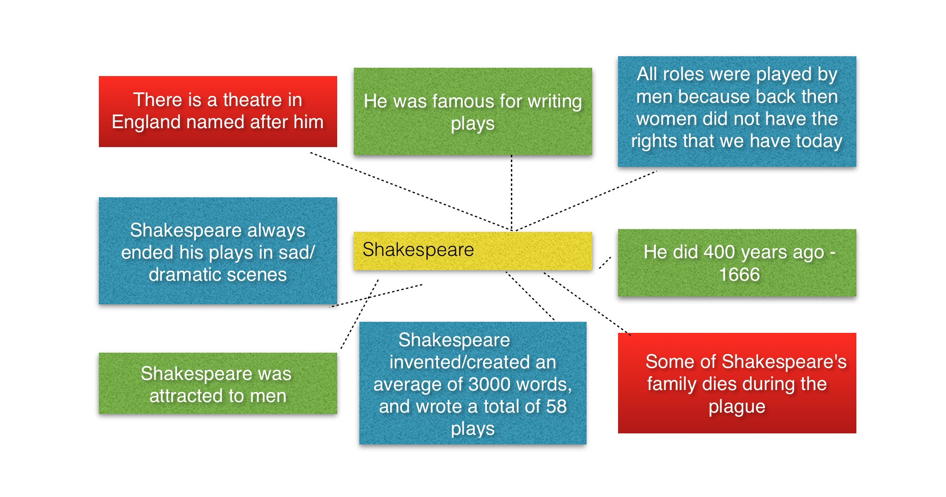

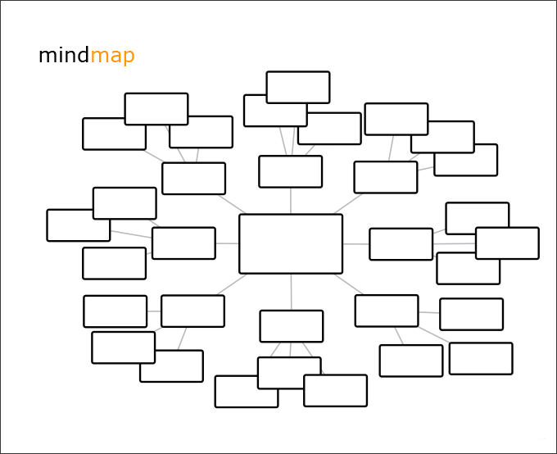

Solomon Northop

Harriet Ann Jacobs

Harriet Beecher Stowe

